- Upload prescription not working
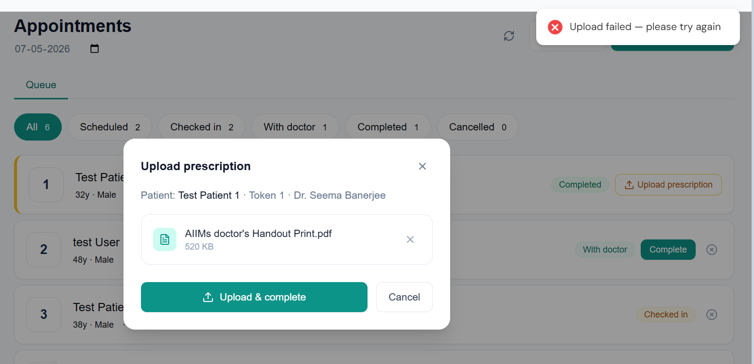
- Once a session for a doctor is ended for that day, it should not more appear on the OPD sessions tab. Like for the below example – I have clicked on end session for Dr. Seema Banerjee and it shows “Start Session” again – the session should end and the row should be greyed out with a timestamp of when the session was ended
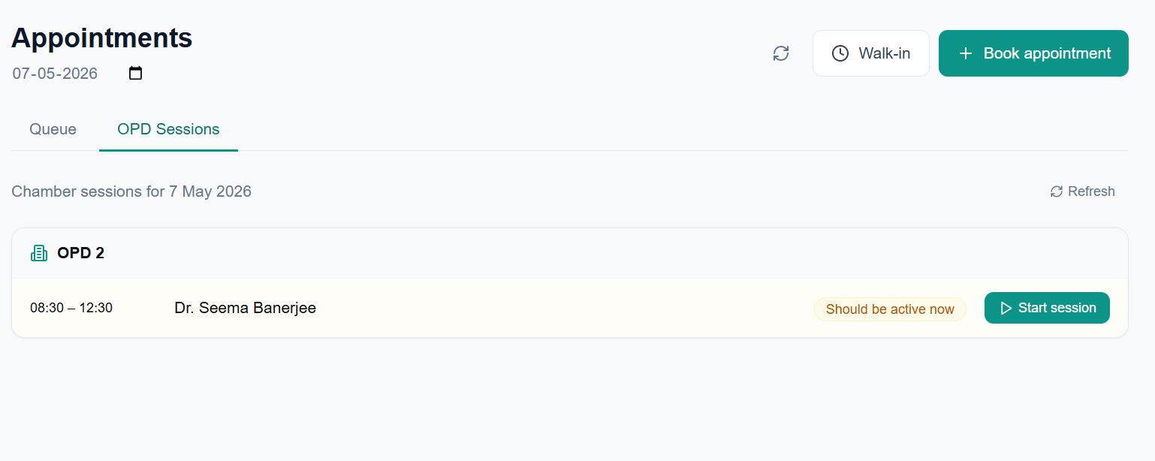
- If I click on “Write prescription” and then save prescription from doctor’s screen (OPD Page from the doctor’s screen) – the status for that patient still remains as “Checked-in” on the receptionist screen whereas it shows as completed on the doctor’s screen (the screenshot below)
- For the above case – in the receptionist screen -> OPD page – the status of the patient still shows as “with doctor”
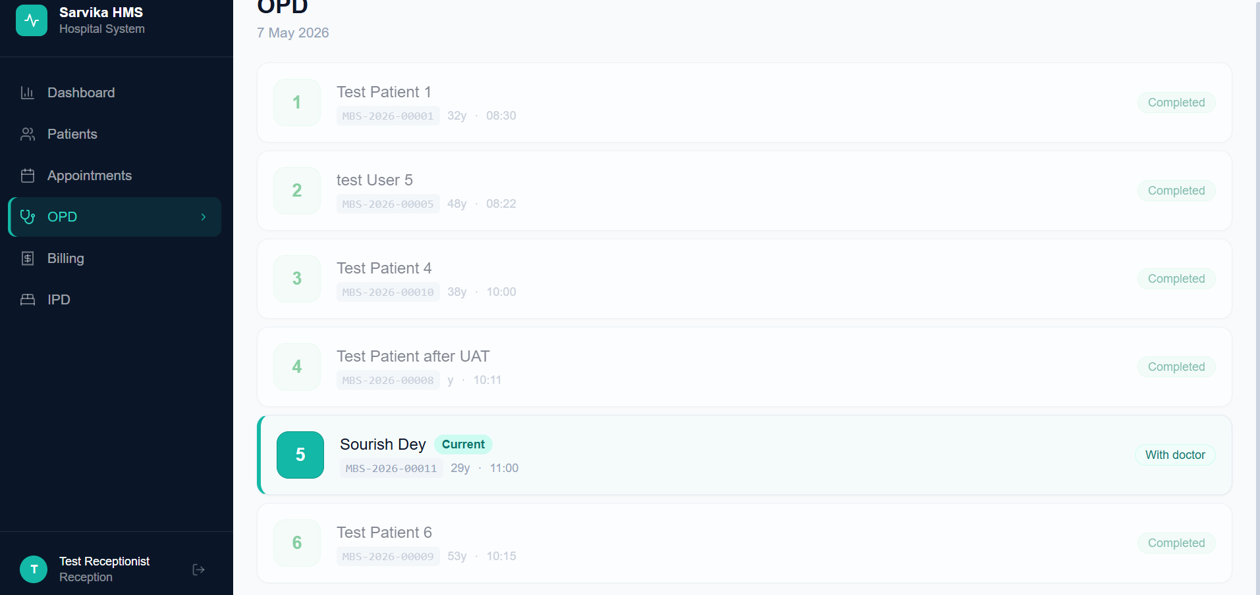
- In the receptionist screen – the “Next button” is still not there (neither in the OPD page nor in the appointments page)
